TireMate Instalation Guide

- Server
  - Install SQL Server 2000 (Please set sa password as Blank)
  - Restore TireMate Database (TireMate_01 , TireMate_02 , …) be tedade Store haee ke darid.
  - Yek Folder (Directory) be name TireMate bar rooye server ijad konid.Mohem Nist dar kodoom Drive bashad.
Sepas In shakhe ra SHARE namaeed.
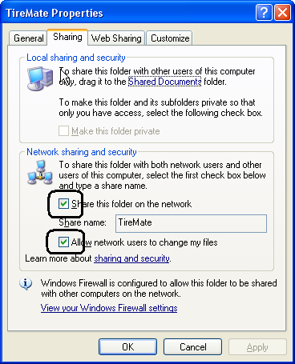

  - Yek Folder (Directory) be name Bin dar zire Shakheye TireMate ijad konid .
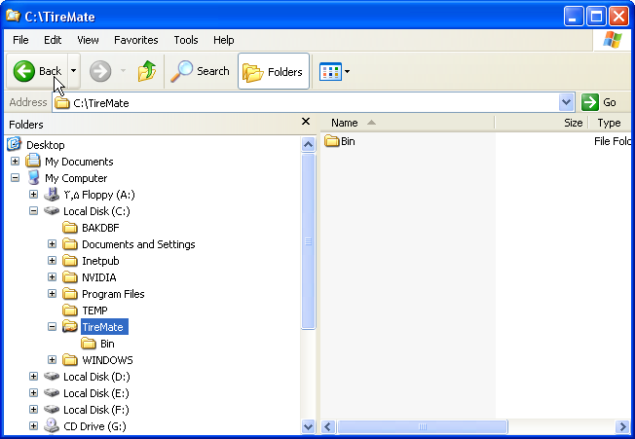

  - Zip File Bin.exe ra dar shakheye bin Unzip namaeed.be toori ke file haye barnameh , dar shakheye Bin copy Shavand.
  - TireMatesetup.mdb ra dar shakheye Bin Baz namaeed.(ba barnameye Access)
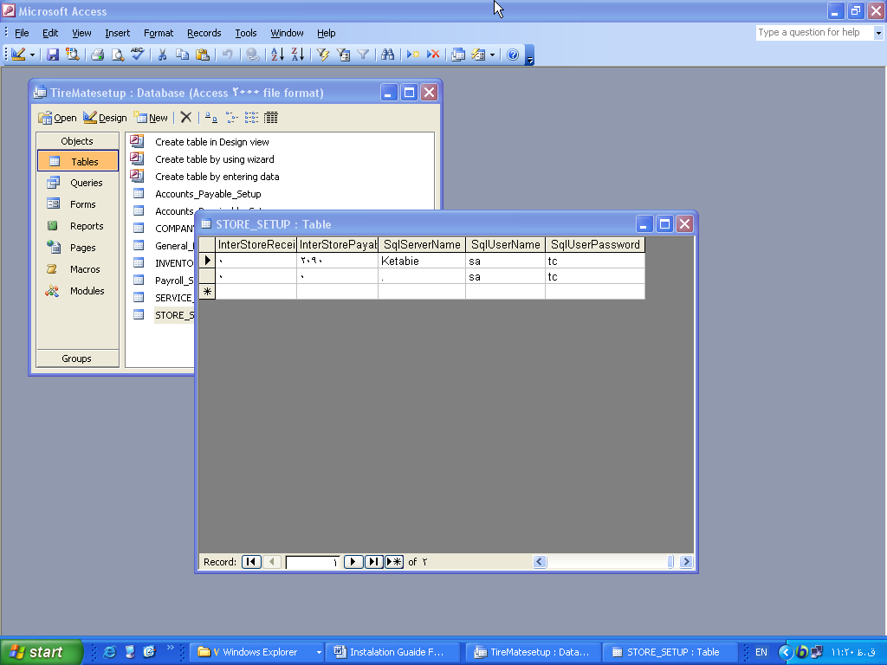

Dar “STORE_SETUP” Table Baraye har STORE yek Record bayad bashad.
Dar field SqlServerName , Server Name ra gharar dahid.
in name ra dar SQL Enterprise Manager mitavanid bebinid.
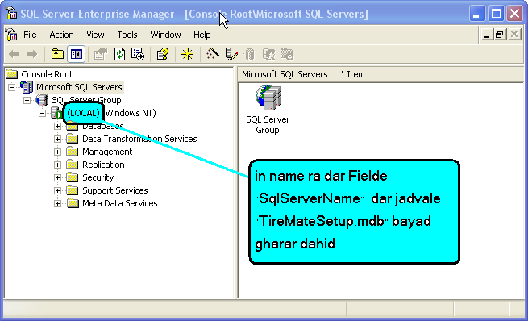
Nokteh : mamoolan Server name ra ba right Click bar rooye My Computer mitavan did.
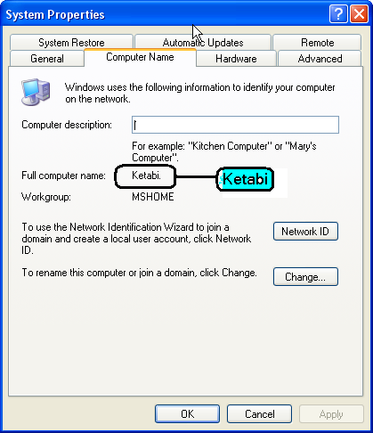

- Clients
  - Install .Net FrameWork 1.1 (dotnetfx.exe)
  - Install Setup (Setup.Exe).ba in kar Yek Short Cut bar rooye Desktop ijad mishavad.
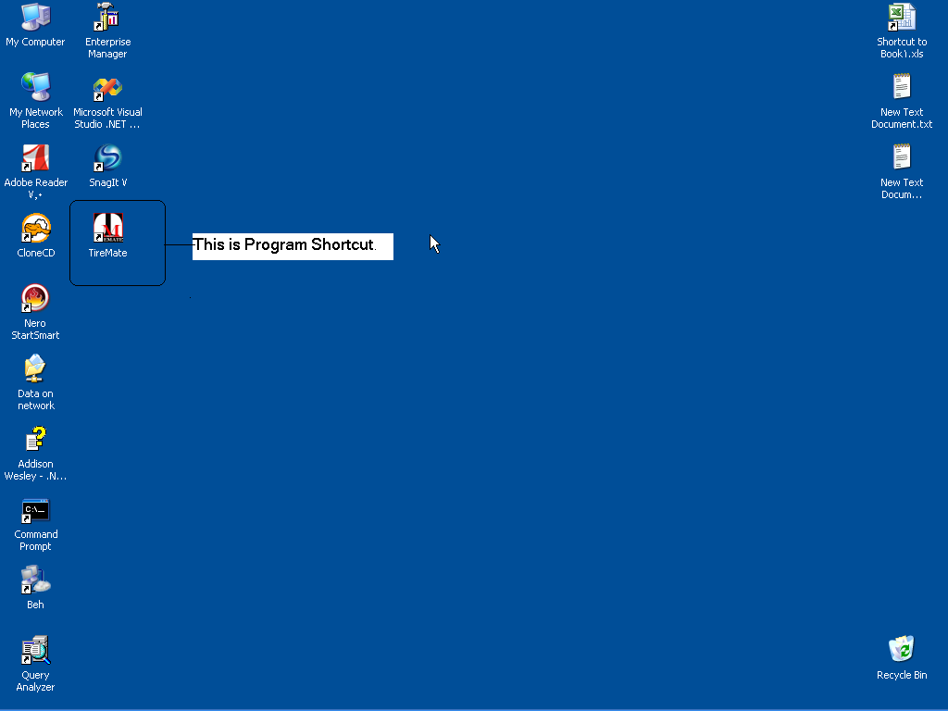

  - Map TireMate Directory To Y:(nokte : in shakhe dar rooye Server gharar darad)
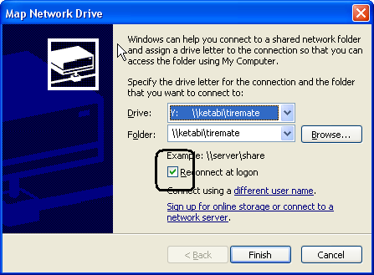

Dar in halat shoma vaghti my computer ra baz mikonid va DRIVE Y: ra entekhab mikonid, Foldere Bin ra mitavanid bebinid.
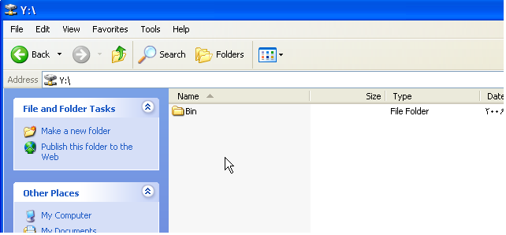

Now you can run TireMate by Double clicking on this shortcut

